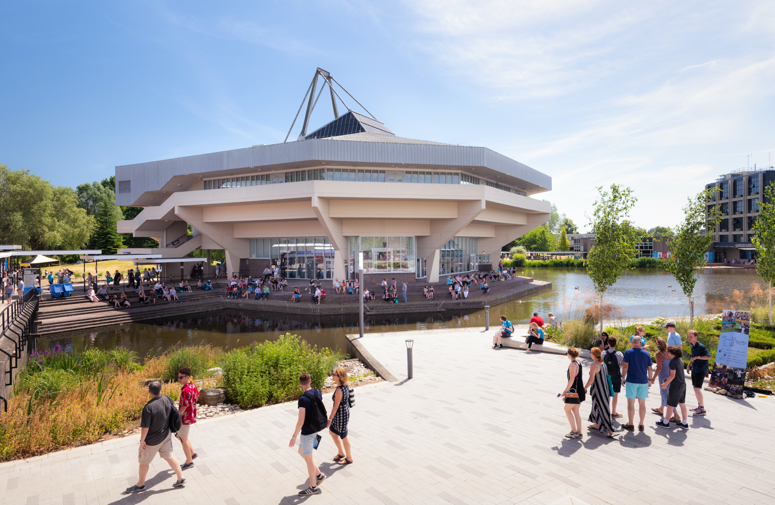

2020-21 PGCE Placement 1 Review 1 - Example

For completion by the School Mentor and Trainee on PebblePad, with an optional comment from the Professional Tutor.
The deadline for the review to be completed is Friday 11 December 2020.
--------------------------------------------------------------------------------------------------------------------------
The screenshot below shows the place where the review should be completed on PebblePad.
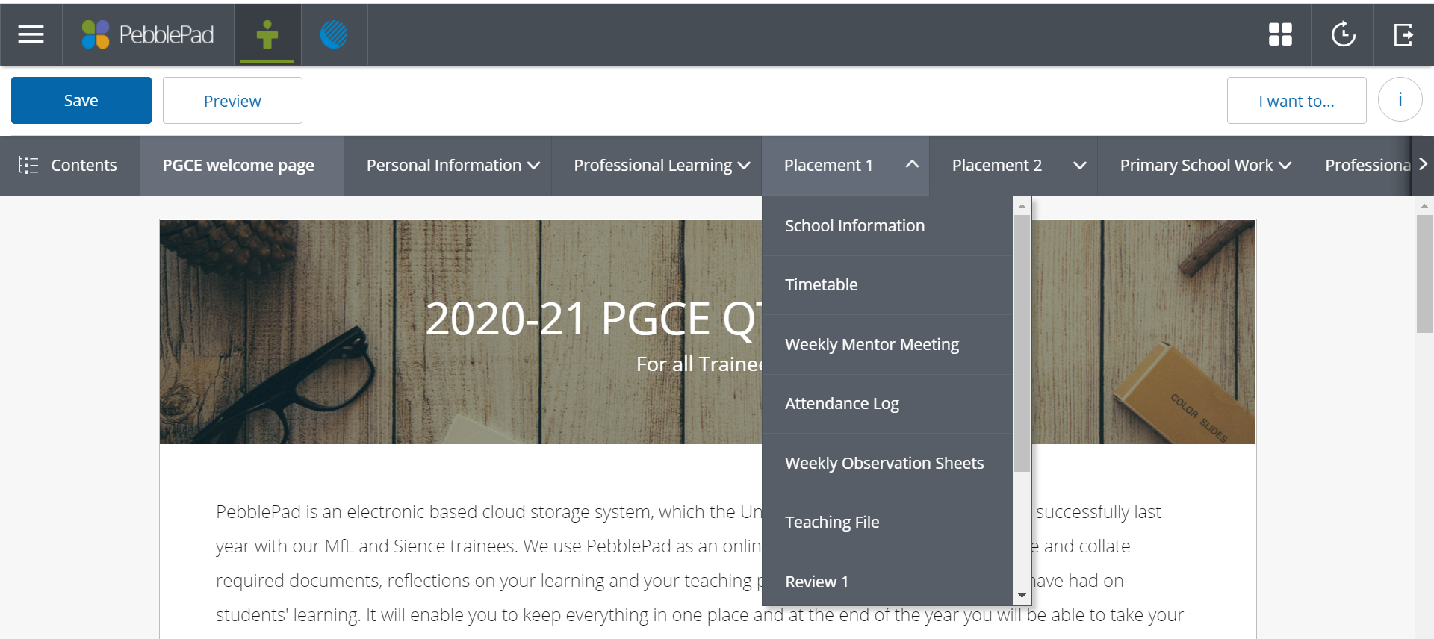

PGCE Placement 1 Review 1

Part A: School Evaluation

Name of Trainee:
Subject:
School:
Subject Mentor:
Professional Tutor:
Date of Review:
Total Possible Number of Days in School:
Number of days absent (illness): Please do not count self-isolation as a day of illness, unless the trainee was ill with C19/ symptoms and unable to work from home. Periods of self-isolation should be recorded under (other).
Number of days absent (interview):
Number of days absent (other):
Placement 1 Block 1 absence total:

Professional Tutor’s Comment (optional) on Trainee’s Placement and/or Review:

Professional Tutor’s Signature: Date :

Making reference to the Teachers’ Standards as appropriate, please comment in the box below on the trainee’s early progress, during the first part of Placement 1. e.g. How well has the trainee settled into their first placement and formed effective professional relationships with colleagues? How well has the trainee reflected upon their early teaching and adapted it accordingly? How well has the trainee responded to advice/feedback? How well has the trainee worked with their weekly development targets? Is the trainee showing early signs of healthy and sustainable working habits?
X has made a very positive start at Y School in these first few weeks of their teaching practice. A particular strength has been their subject knowledge (TS3), which has been particularly evident in the coasts lessons that have been taught with Yr 8. I have been impressed with the time and effort that has been put into teaching well planned lessons (TS4), with careful consideration of individual needs within their classes (TS5). X always has structured support for those students who need it and is starting to show confidence in varying their levels of questioning to gauge the classes progress and understanding (TS6). X is also using and amending departmental resources alongside their own planning, which is a sensible approach to ensuring that the current level of planning can be sustained.

Has the trainee taught at least 8 solo lessons, including one small sequence of 2-3 lessons with one class: On pebblePad this is a click box Yes/No question. We appreciate that changes to the end of term may have meant that 8 solo lessons have not been taught.

Making reference to the Teachers’ Standards in what ways and how well is the trainee starting to impact upon pupils’ learning and progress? (You may find it helpful to refer to the “Pupil Progress Prompt Sheets”)
X is establishing clear routines with their classes, ensuring the students arrive in an orderly manner and the lessons start straight away. This ensures that learning time is maximised, which has been achieved through setting and reinforcing consistently high expectations (TS1 and 9)
In Yr 8 Pupils have shown increasing confidence when explaining the formation of landforms, linked to specific geographical processes. This is a result of secure subject knowledge and careful explanations from X (TS3 and TS4).
X is having a positive impact on the behaviour for learning in their Year 7 class. Pupils receive more rewards, which are given out consistently and time has been taken to build positive and professional relationships with students (TS7).

Making reference to the Teachers’ Standards (Preamble & Part Two), please comment in the box below on the trainee’s Personal and Professional Conduct:
X has 100% attendance so far and has always been punctual and professionally dressed for teaching. X is clearly demonstrating the school values in their approach to teaching, showing forgiveness through their ability to wipe the slate clean each lesson, whilst showing compassion and kindness to students who are struggling through the C19 restrictions. X has shown a very good awareness of the need to safeguard young people, raising concerns that they may have with both myself as mentor and the schools designated safeguarding lead when needed. X is always on time with their lesson planning and copying of resources, which leads to excellent organisation in the classroom.

Has the trainee demonstrated appropriate professional competency with literacy and numeracy?

Yes/No (Please comment in the box below if “No”)
Please note, there is no need to comment if you click Yes

Using the QTS assessment booklet and in discussion with the trainee, please record in the table below the trainee’s progress towards meeting Part One of the Teachers’ Standards where:

WT = Working Towards Meeting that Standard

BS = Below Standard

Please note that at this stage of their training it is anticipated:
- the majority of trainees will be working towards (WT) all eight Standards;
- a small number of trainees will have one or more Standards judged to be Below Standard (BS).
Please note, this section is a click box section in PebblePad
Standards: | WT/BS
TS1: Set high expectations which inspire, motivate and challenge pupils. | WT
TS2: Promote good progress and outcomes by pupils. | WT
TS3: Demonstrate good subject and curriculum knowledge. | WT
TS4: Plan and teach well-structured lessons. | WT
TS5: Adapt teaching to respond to the strengths and needs of all pupils. | WT
TS6: Make accurate and productive use of assessment | WT
TS7: Manage behaviour effectively to ensure a good and safe learning environment. | WT
TS8: Fulfil wider professional duties. | WT

Please comment briefly in the box below whether the evidence suggests, at this stage, that the trainee is on a trajectory towards meeting the Standards by the end of their ITT year:

Although, X has only taught 7 solo lessons so far, they have demonstrated improvements across their early teaching through careful reflection and evaluation of their performance. X clearly acts upon the feedback that has been given and if they continue to progress in the same way, I am confident that they should be on a trajectory to meet the teacher standards by the end of the year.

Please note clearly any concerns, including about professionalism, you have at this stage of training:
No concerns at this stage

In discussion with your trainee please list 3 development targets (linked to the Teachers’ Standards) and suggest concrete actions the trainee can take to help them achieve these targets. Please note: Set one target that builds on an emerging strength/aspect of teaching the trainee enjoys.

On PebblePad, this section is an open textbox. Please use the headings suggested to provide clarity of target.
Target area: | Actions to achieve targets:
Subject Specific:  Ensure lessons include locational context as well as specific and up to date figures/ data to ensure that students can connect the lesson to their wider understanding of the world (TS 3 & TS4). | Increase your use of Google Earth as a demonstration tool in lessons. Use ‘Our World in Data’ for accessing relevant data to support your lessons.
General Teaching and Learning:  Increase the use of retrieval practise in your lessons to improve the students’ ability to bring information into their working memory when needed (TS2 & TS6). | Include a weekly low stakes quiz for all classes, which focuses on recently learnt content as well as content covered in their previous topics.
General Teaching and Learning:  Increase the pace of tasks, ensuring there is challenge materials ready for those students who need it (TS4 & TS5). | Use of timers on the board to ensure that tasks do not drag on. Every task should have an open ended Bright Sparks challenge at the end.

Finally, in the box provided below, please suggest particular professional development opportunities the trainee might/should pursue in the second part of Placement 1 to enrich themselves professionally. These may be linked to the targets you have agreed with the trainee or could be wider training opportunities.
To further their role as a form tutor, X should aim to deliver the PSHCE programme and should work alongside teacher Q to complete the pastoral form reports. To gain an understanding of the NEA at KS5, X should shadow teacher Z when first marking the NEA. X will also be taking part in the fieldwork trip to the Holderness Coastline with Yr 8 so should familiarise themselves with the lessons that lead up to and follow this trip.

Signed (Mentor): | This can be your typed name on PebblePad | Date:
Signed (Trainee): |  | Date:

PART B: Trainee Self-Evaluation
Please note, this section on PebblePad should be completed by the trainee.

